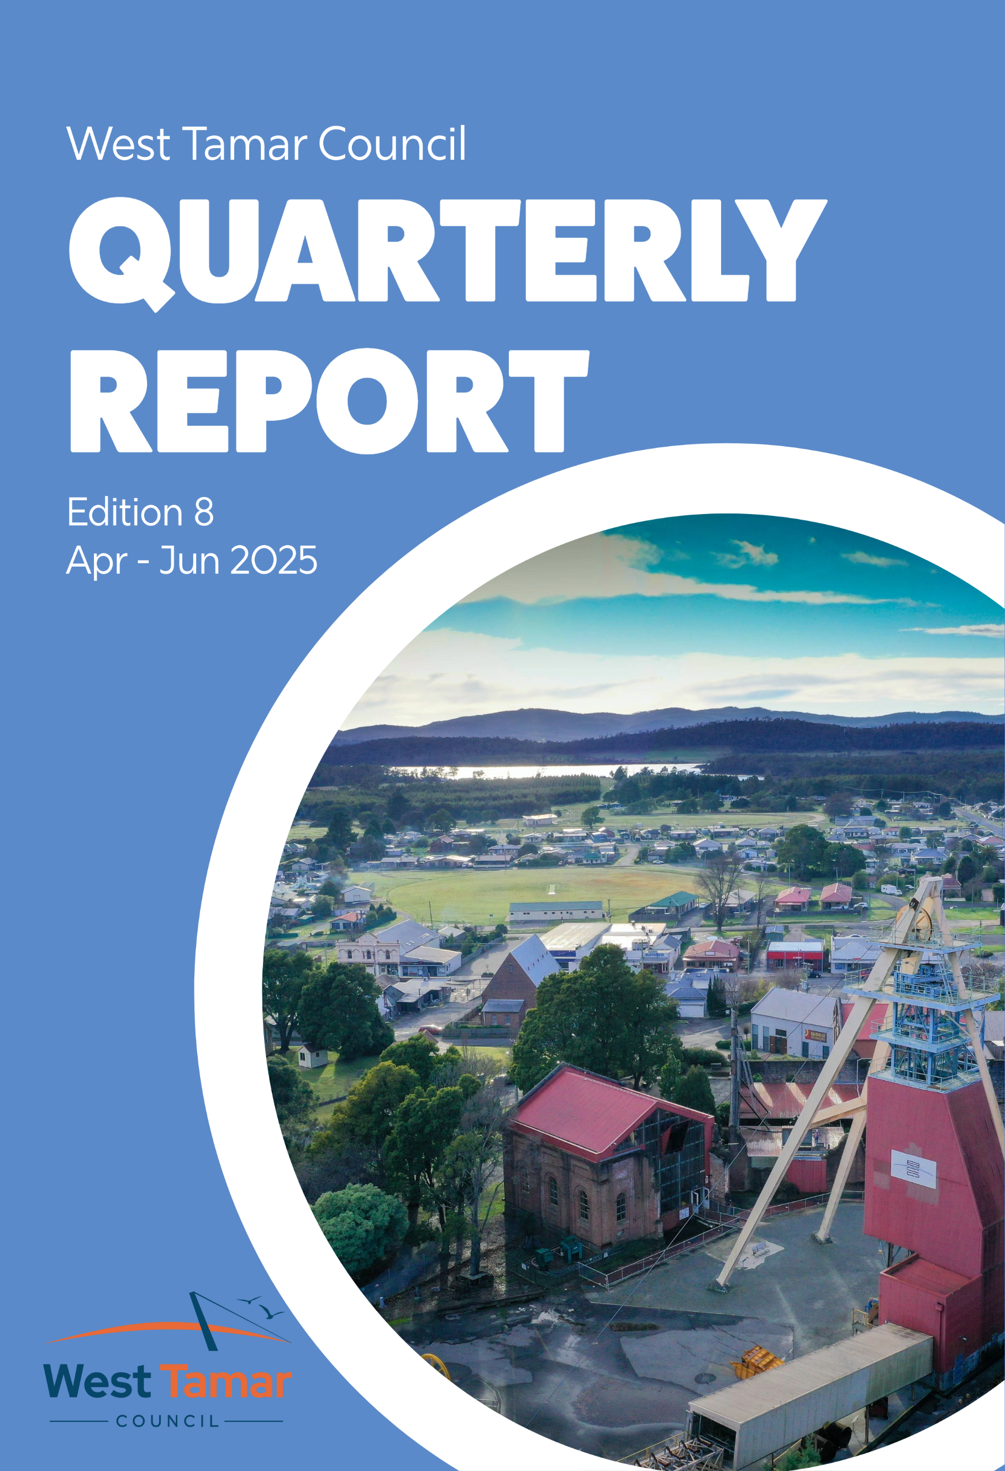
Table of Contents
Message from the CEO 3
CEO Meeting Schedule 4-5
Use of the Council Seal 6-7
Audit Panel Actions 8
Financial Reports 9-10
Service Delivery 11-12
Compliance 13-14
Community 15-18
Key Project Update 19-20
Workforce 21
Incident Reporting 22
Appendix 1 – Capital Works Program 23-29
Appendix 2 – Annual Plan Report 30-34
Appendix 3 – Outstanding Motions 35-44
Message from the CEO

I am pleased to share with you the highlights from the fourth and final quarter of the 2024-25 financial year. This quarter has been marked by continued progress and achievements across Council.
I am delighted to report that our customer service request compliance was once again above 98%. The 2024/25 year has not seen a customer service request compliance level below 97%. This ensures that our community has a responsive council that meets its needs. Thank you to all Council Officers who ensure that our community receive such fantastic customer service.
Our community engagement initiatives have continued to go from strength to strength. We officially opened the $2 million redevelopment of Windsor Park in May, and commemorated Anzac Day at Beaconsfield’s RSL Park on April 25 with an 11am service, which drew an audience of hundreds of people and service groups.
There was less net capital expenditure activity for the quarter than previous quarters for the financial year with net capital expenditure of $5.6m earmarked for carryover into the 2025-26 financial year capital budget.
It was very pleasing to see increased visitation at the Beaconsfield Mine and Heritage Centre with over 34,000 visitors in the 2024/25 financial year, up from just over 30,500 in the 2023/24 financial year.
I would like to again thank Council staff for their continued dedication and hard work and I look forward to reporting on what I am sure will be a very busy 2025/26 financial year.



Kristen Desmond
Chief Executive Officer
CEO Meeting Schedule
Quarter 4, 2024-25 – April to June 2025
April
1 | Interim Workshop
2 | LGAT General Meeting, Hobart
4 | Official Opening – Legana Primary School
 | NTRLUS Steering Committee Meeting
5 | Relay for Life
8 | Budget Workshop
9 | Meeting with Brand Tasmania
10 | Catch up with Visit Northern Tasmania
 | Networking lunch with NTDC
 | TasTafe Networking event
11 | Meeting with Sidmouth Hall Committee
 | Media event – TEER
 | Northern General Manager/CEOs Regional Meeting
14 | Meeting with Rate Payer
 | Meeting with Rate Payer
 | Meeting with Mayor
15 | Pre-Meeting Workshop and Ordinary Council Meeting
16 | Meeting with Minister Oglivie
 | Meeting with TOMRA Cleanaway
 | 2025 CareSuper Business Excellence Awards Launch Event
17 | Meeting with prospective land purchaser
 | Meeting with local community group
 | Meeting with sporting club
 | Meeting with sporting club
24 | Media event
 | Meeting with prospective land purchaser
25 | Beaconsfield ANZAC Day 11am service
28 | International Workers Memorial Day Breakfast
 | Launceston Chamber of Commerce and TasICT CoPilot training
 | Consultation meeting with Independent Review Panel of RTI Framework in Tasmania
29 | Meeting with local business owner
May
1 | Meeting with Rate Payer
5 | CBOS Permit Authority Forum
6 | Interim Workshop
7 | Meeting with Libraries Tasmania
 | RDA Tasmania – Launch of the 2025 Tasmania Economic review webinar
 | NTRLUS Regional Strategic Directions – Local Government Workshop
8 | Meeting with prospective land purchaser
 | Meeting with prospective land purchaser
12 | Meeting with Launceston Chamber of Commerce and Mayor
15 | Sustainable Tourism Growth Workshop
 | Meeting with CEO City of Launceston Council
 | Local Government Workshop on Guideline for Community Engagement, Benefit Sharing and Local Procurement
20 | Pre-meeting Workshop and Ordinary Council Meeting
21 | Launceston Chamber of Commerce Tamar Valley Leaders Lunch – Speaker
22 | Meeting with organisation
 | Turner Stillhouse Whisk(e)y Launch
23 | The Valley Church – Australia’s Biggest Morning Tea
25 | Winkleigh Hall – Australia’s Biggest Morning Tea
26 | Meeting with Hall Committee
 | Meeting with West Tamar Community Carols Committee
 | Meeting with Mayor
27 | TEMT Infrastructure Master Plan Workshop
28 | 2025 National Reconciliation Week Breakfast
 | Launceston Events Strategy/Convention Demand Study Reference Group Meeting
 | Meeting with tenant
29 | Meeting with business owner
30 | NTRLUS Meeting
 | 2025 State Budget Lunch
31 | Official Opening – Windsor Oval
June
2 | Meeting with sports representatives
 | Rowella Hall Committee Meeting
3 | Interim Workshop
 | Infrastructure and Amenity Steering Committee meeting
4 | West Tamar Council Audit Panel Quarter 4 meeting
5 | Meeting with sporting club
6 | 2025 State Budget Reply Breakfast
 | Northern General Manager/CEOs Regional Meeting
10 | Meeting with WLF regarding Emergency Management
 | Meeting with Office of the Coordinator General
 | Meeting with sports representatives
11 | Meeting with proponent
12 | Waste Not event
13 | Meeting with Rate Payer
 | Tour of local business facilities
16 | TEMT Meeting
 | Meeting with sporting club
17 | Pre-meeting Workshop and Ordinary Council Meeting
 | Business Events Tasmania Catch up
18 | NTRLUS update
19 | Meeting with Minister Jo Palmer
 | Citizenship Ceremony
20 | Circular North Steering Committee Meeting
 | NTDC SGM & MRG
 | George Town Council – Solstice in the Square
23-27 | ALGA Conference, Canberra
26 | National Local Government Professionals Breakfast
30 | Meeting with Minister Jo Palmer
 | West Tamar Council Community Carols Committee Meeting
Use of the Council Seal
Date Common Seal Affixed | Reference No | Document Under Seal | Applicant/Other Party | Names of Signatories
07.04.2025 | CS-165 | Grant Agreement – EC24-154 Legana Community Sport and Recreation Plan | The Crown in Right of Tasmania | CEO Kristen Desmond, Mayor Christina Holmdahl
14.04.2025 | CS-166 | PA2023235 Final Survey Diagram and Schedule of Easements | Radian Surveying | CEO Kristen Desmond, Mayor Christina Holmdahl
14.04.2025 | CS-167 | PA2023258 Final Survey Diagram and Schedule of Easements | Cohen & Associates Pty. Ltd. | CEO Kristen Desmond, Mayor Christina Holmdahl
14.04.2025 | CS-168 | PA2023270 Final Survey Diagram and Schedule of Easements | D J McCulloch Surveying | CEO Kristen Desmond, Mayor Christina Holmdahl
14.04.2025 | CS-169 | PA2024159 Final Survey Diagram and Schedule of Easements | Cohen & Associates Pty. Ltd. | CEO Kristen Desmond, Mayor Christina Holmdahl
14.04.2025 | CS-170 | PA2023323 Final Survey Diagram and Schedule of Easements | Cohen & Associates Pty. Ltd. | CEO Kristen Desmond, Mayor Christina Holmdahl
17.04.2025 | CS-171 | Contract of Sale for Lot 3, Legana Park Drive | OPT Tasmania Pty Ltd | CEO Kristen Desmond, Mayor Christina Holmdahl
12.05.2025 | CS-172 | Data Sharing Agreement | Crown in Right of Tasmania | CEO Kristen Desmond, Mayor Christina Holmdahl
14.05.2025 | CS-173 | Beaconsfield Community Sport and Recreation Plan | Crown in Right of Tasmania | CEO Kristen Desmond, Mayor Christina Holmdahl
14.05.2025 | CS-174 | PA2022507 Final Survey Diagram and Schedule of Easements | Radian Surveying | CEO Kristen Desmond, Mayor Christina Holmdahl
21.05.2025 | CS-175 | Grant Deed - Caravan and Motorhome Plan – Council Infrastructure Grants in duplicate | Crown in Right of Tasmania | CEO Kristen Desmond, Mayor Christina Holmdahl
21.05.2025 | CS-176 | Grant Deed – Grant Program: isolated Communities Resilience Grants – Stream 2 | Crown in Right of Tasmania | CEO Kristen Desmond, Mayor Christina Holmdahl
21.05.2025 | CS-177 | Deed of Agreement under the Land Use Planning and Approvals Act 1993 re Certificate of Title Vol 188449 Folio 1000 | West Tamar Council (as Council) | CEO Kristen Desmond, Mayor Christina Holmdahl
21.05.2025 | CS-178 | Deed of Agreement under the Land Use Planning and Approvals Act 1993 re Certificate of Title Vol 188449 Folio 1000 | West Tamar Council (as Owner) | CEO Kristen Desmond, Mayor Christina Holmdahl
26.05.2025 | CS-179 | Grant Deed – Kelso Public Toilets and Parking – EC21-035 | Crown in Right of Tasmania | CEO Kristen Desmond, Mayor Christina Holmdahl
26.05.2025 | CS-180 | PA2023293 Final Survey Diagram and Schedule of Easements | D J McCulloch & Associates | CEO Kristen Desmond, Mayor Christina Holmdahl
05.06.2025 | CS-181 | Cancellation of Seal – PA2015165 Final Survey Diagram and Schedule of Easements - original Seal placed 20 September 2017 | Land Titles Office & Registry of Deeds | CEO Kristen Desmond, Mayor Christina Holmdahl
10.06.2025 | CS-182 | Grand Deed – Grant Program: Isolated Communities Resilience Grants – Stream 3 | Crown in Right of Tasmania | CEO Kristen Desmond, Mayor Christina Holmdahl
18.06.2025 | CS-183 | PA2022152 Final Survey Diagram and Schedule of Easements | Woolcott Land Services | CEO Kristen Desmond, Mayor Christina Holmdahl
20.06.2025 | CS-184 | Deed of Variation of Funding Agreement – FA00003403 Tasmanian Councils supporting climate healthy and resilient communities | Crown in Right of Tasmania | CEO Kristen Desmond, Mayor Christina Holmdahl
30.06.2025 | CS-185 | PA2024234 Final Survey Diagram & Schedule of Easements | Survey & Alignment Services | CEO Kristen Desmond, Mayor Christina Holmdahl
30.06.2025 | CS-186 | PA2024151 Final Survey Diagram & Schedule of Easements | Cohen & Associates | CEO Kristen Desmond, Mayor Christina Holmdahl

Audit Panel Actions
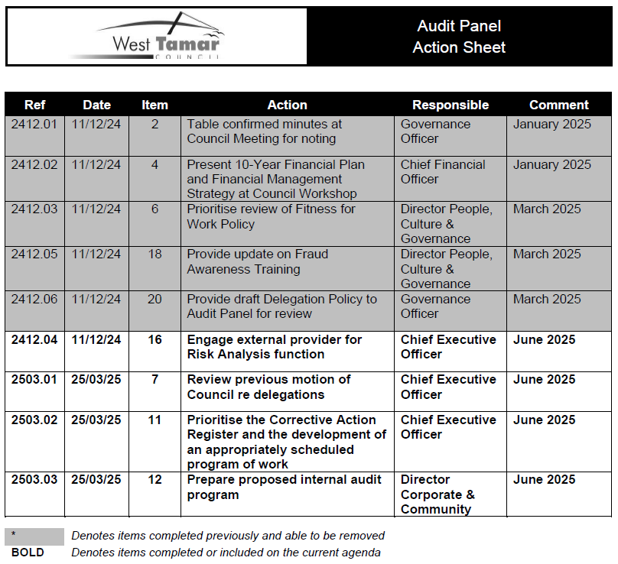
Financial Reports

Grants for the quarter are ahead of budget due to the unexpected and unbudgeted 50% prepayment of 2025-26 financial assistance grant allocations.
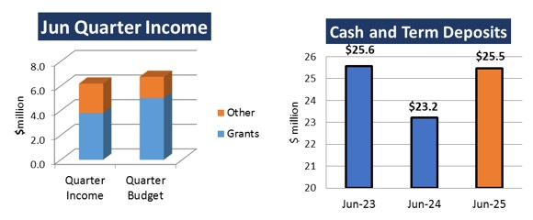

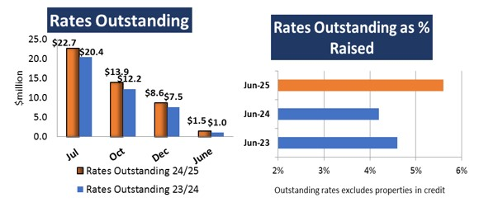

Rates outstanding at year end has increased $0.4m from the balance 12 months earlier with over 5% of rates still outstanding as at 30th June.

Financial Reports

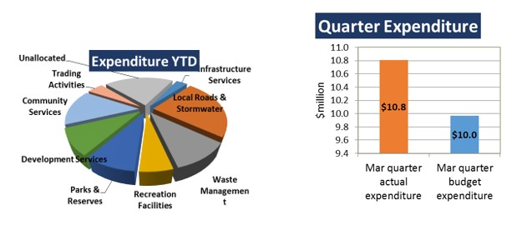
Operational expenses for the quarter are above budget, mainly driven by accelerated depreciation of $1.1m on the Exeter Child Care Centre building to recognise the future ownership transfer of this building. Employee costs were under for the quarter but more than offset by the use of labour hire reported under materials and services.

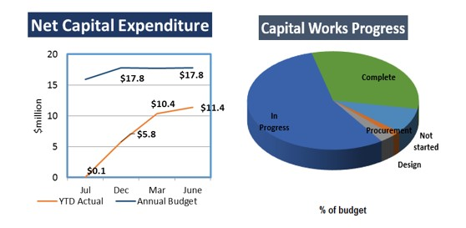

There was less net capital expenditure activity for the quarter than previous quarters for the financial year with net capital expenditure of $5.6m earmarked for carryover into the 2025-26 financial year capital budget.
Service Delivery
Customer Service Requests
- 462 total Customer Service Requests
- 454 compliant
- 8 non-compliant
- 98.27 per cent compliant
- Works and Infrastructure responded to 310 customer service requests during the first quarter

Planning and Development
Description | Previous Year Total | Q3 Mar 25 | Q4 June 25 | Year to Date
S57 Discretionary | 209 | 29 | 55 | 180
S57 Discretionary (avg days) |  | 37.55 | 36.83
S58 Permitted | 56 | 13 | 10 | 42
S58 Permitted (avg days) |  | 12.69 | 13.8
S56 Amended Permits | 35 | 2 | 7 | 21
No permit required/exempt | 112 | 34 | 31 | 125
Planning Appeals | 3 | 2 | 0 | 2

Building

Description | Previous Year Total | Q3 Mar 25 | Q4 Mar 25 | Year to Date
Council issued Certificate of Likely Compliance (COLC) | 92 | 34 | 27 | 107
Privately surveyed (COLC) | 155 | 34 | 44 | 164
Council issued Permits | 24 | 6 | 19 | 45
Privately surveyed Certificates of Substantial Compliance | 12 | 0 | 6 | 10
Inspections | 420 | 787 | 120 | 383

Plumbing
Description | Previous Year Total | Q3 Mar 25 | Q4 Jun 25 | Year to Date
CoLC/Permit:
West Tamar Council | 191 | 35 | 39 | 167
Dorset Council | 52 | 7 | 9 | 40
George Town Council | 243 | 28 | 23 | 94
Flinders Island Council | 12 | 5 | 6 | 18
Inspections:
West Tamar Council | 718 | 158 | 130 | 550
Dorset Council | 87 | 16 | 13 | 68
George Town Council | 174 | 28 | 72 | 173
Flinders Island Council | 18 | 0 | 7 | 7
Drainage Nuisances: | 61 | 15 | 13 | 59

Compliance

Development Compliance
Description | Previous Year Total | Q3 Mar 25 | Q4 Jun 25 | Year to Date
Complaints received and investigation initiated | 78 | 13 | 19 | 62
Building orders issued | 45 | 12 | 10 | 47
Plumbing orders issued | 14 | 4 | 3 | 18
Planning notice of intent | 12 | 1 | 1 | 3
Planning Enforcement notice issued | 6 | 1 | 0 | 1
Matter resolved - withdrawn | 10 | 0 | 1 | 5
Matter resolved – satisfied/revoked | 32 | 3 | 2 | 15
There were 222 ongoing compliance matters during the June quarter 2025
Environmental Health
Description | Previous Year Total | Q3 Mar 25 | Q4 Jun 25 | Year to Date
New food business applications approved |  | 3 | 1 | 16
Food business inspections - number |  | 73 | 69 | 250
Vaccinations administered – number |  | 0 | 0 | 0
Complaints received and investigations initiated - number |  | 16 | 23 | 77
Complaints resolved - number |  | 12 | 21 | 61
Notifiable disease investigations |  | 8 | 3 | 15
OWMS consent |  | 11 | 10 | 44
OWMS inspections |  | 6 | 6 | 73

Compliance

Municipal Inspectors
Description | Previous Year Total | Q3 Mar 25 | Q4 Jun 25 | Year to Date
Dog registrations - number |  | 4301 | 4171
Dogs at large detained - number |  | 2 | 21 | 75
Barking dog complaints investigated - number |  | 2 | 1 | 6
Dog attacks investigated – number |  | 4 | 9 | 21
Burials - number |  | 2 | 7 | 16
Internment of ashes - number |  | 0 | 0 | 5
Fire abatement inspections - number |  | 47 | 0 | 114
Fire abatement notices issued - number |  | 37 | 0 | 80


Community

Event highlights
JUNE CITZENSHIP CEREMONY
In late June, West Tamar Council celebrated its latest Citizenship Ceremony, welcoming 12 new Australian citizens to our community.
Our amazing conferees came from Sri Lanka, Iran, New Zealand, Nepal, Taiwan, the Philippines and South Africa.
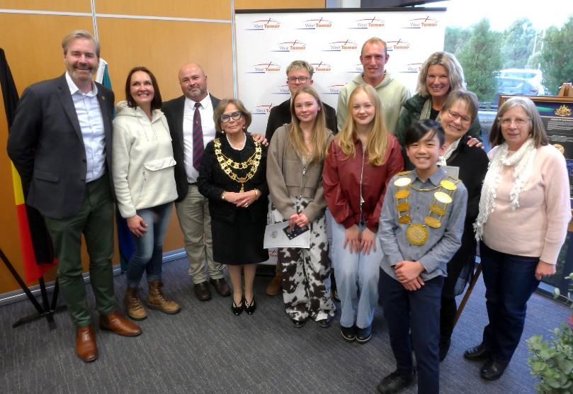



Congratulations to everyone and thank you for choosing the West Tamar as your home.
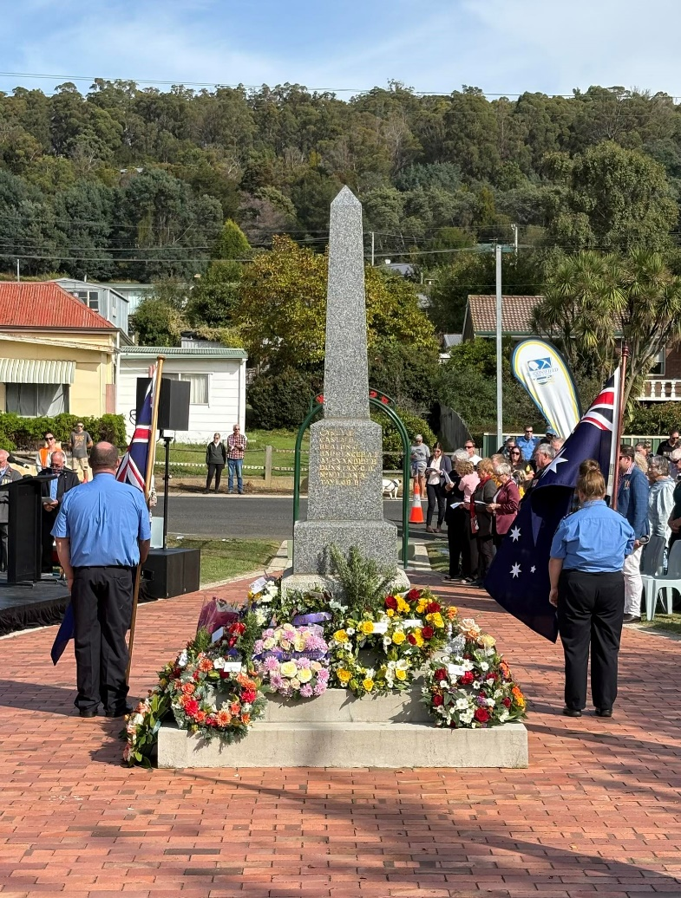
Community

ANZAC DAY 2025
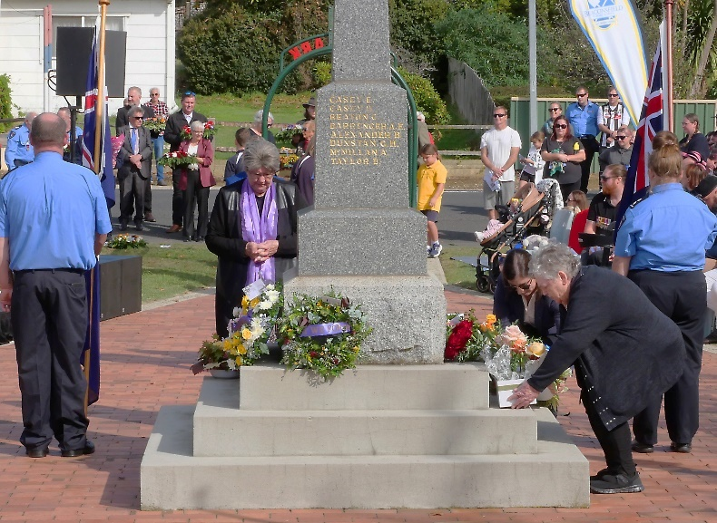
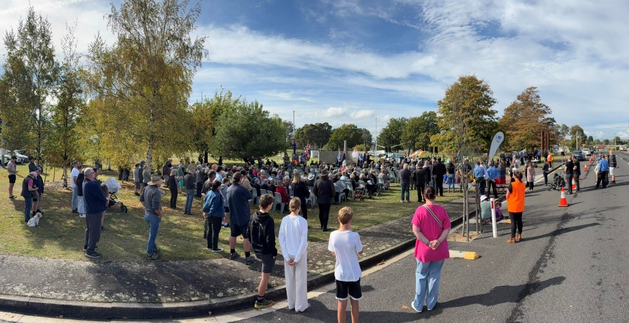
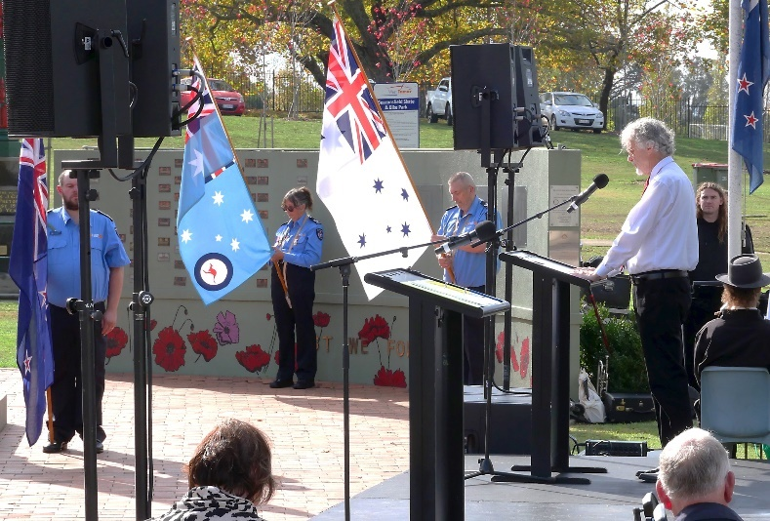
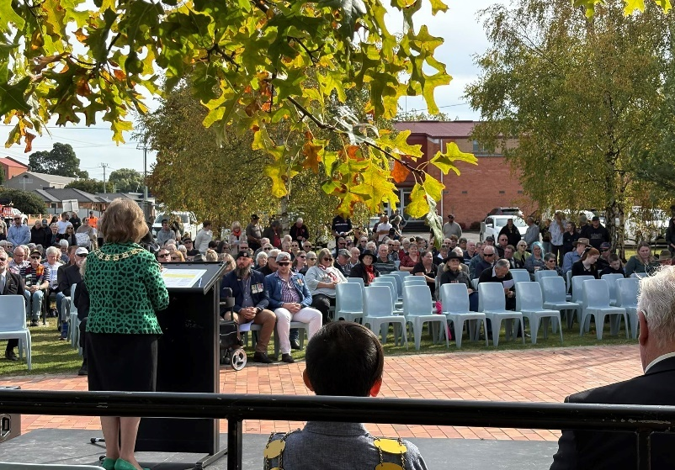
The West Tamar Council commemorated Anzac Day at Beaconsfield’s RSL Park on April 25 with a packed 11am service, with hundreds of people and service groups in attendance.

Windsor Community Precinct
The following events were considered as highlights for the precinct during the quarter:
- In April, the Department of State Growth hosted the Tamar River Crossing Consultation in the Community Hall.
- While there was a break over the Easter Holiday, the Community Team – in conjunction with the Beaconsfield RSL hosted another Anzac Day commemoration.
- In May, the team celebrated the opening of the Windsor Oval. The Community Hall hosted the Federal Election while the May ordinary Council Meeting was held for the first time in the new Windsor Chambers.

 | April | May | June
WCP Halls/Rooms* | 81 | 84 | 92
WCP Recreation | 154 | 159 | 167
SUB TOTAL | 235 | 243 | 259
Riverside Cricket Club/  Riverside Olympic Football Club Rooms** | 40 | 43 | 44
TOTAL | 275 | 286 | 300
*Includes: Amphitheatre and Training Room (Youth Space) **Included to show roster change.

Beaconsfield Mine and Heritage Centre
 |  |  | Groups
Date |  |  |  | Number of entries |  |  | Number of Groups
April |  |  |  | 3139 |  |  | 14 groups
May |  |  |  | 240 |  |  | 6 groups
June |  |  |  | 114 |  |  | 6 groups
 |  |  | Social Media Insights BMHC
Facebook |  |  |  |  | Followers |  |  |  | Post views |  |  | Post Engagement
April  5 Facebook posts |  |  |  |  | 3243 total followers |  |  |  | 10.562 |  |  | Post engagement 1.1k
May  Facebook posts |  |  |  |  | 3240 total followers |  |  |  | 5273 |  |  | Post engagement 896
June  Facebook posts |  |  |  |  | 3251 total followers |  |  |  | 38,107 |  |  | Post engagement 1.5k
 |  | Visitor Figures
 | Year |  |  |  |  | 2022-23 |  | 2023-24 |  | 2022-23 YTD | 2023-24 YTD |  | 2024-25 YTD
 | Visitor Numbers YTD |  |  |  |  |  |  |  |  | 38,251 | 30,542 |  | 34,291
 |  | five-year visitor numbers
 | 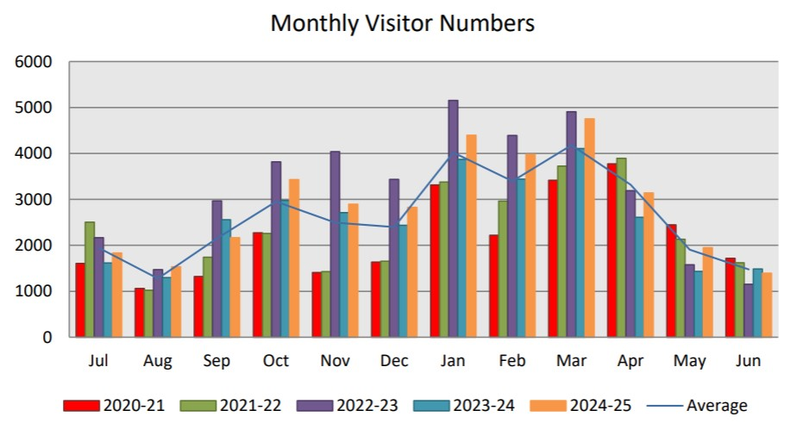
 | 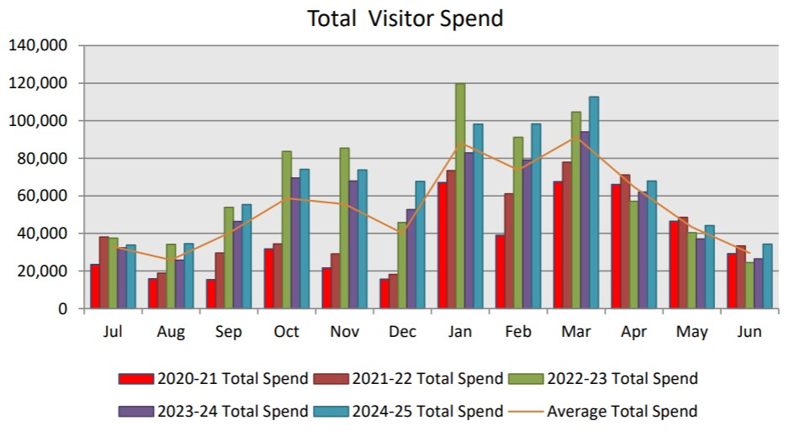

Key Project Update
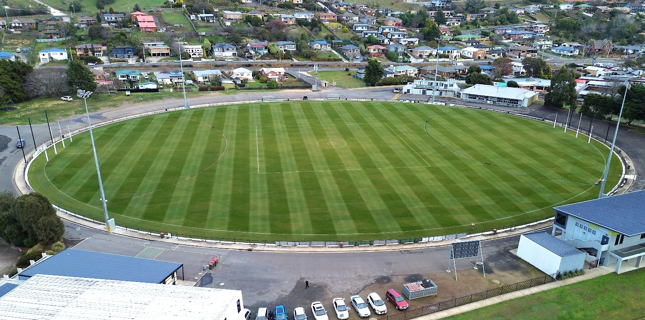
WINDSOR OVAL REDEVELOPMENT
West Tamar Council officially opened its $2 million redevelopment of Windsor Park in May.
Originally constructed in 1968, Windsor Park has been home to the Launceston Football Club for more than half a century.
Mayor Christina Holmdahl officially opened the redevelopment on Saturday, May 31, alongside Launceston Football Club president Scott Stephens and AFL Tasmania’s State Participation and Programs Manager Aaron Roberts prior to the Blues first home game on the new surface against Scottsdale.
Mayor Holmdahl said that the oval has been plagued with drainage issues for a number of years due to the poor condition of the playing surface, specifically over the winter months.
The redevelopment of the oval began in late 2024 with the purpose of delivering the best value playing surface in Northern Tasmania, and improved lighting in accordance with relevant Australian Standards and AFL Guidelines and with minimal environmental and stakeholder impact.
Civil works included the re-leveling of the oval surface, installing new drainage systems, sand slitting, irrigation, the establishment of a 100mm sand mattress, reseeding, as well as new perimeter fencing and improved lighting.
The redevelopment of Windsor is the second major sporting oval project the Council has completed in the past six months following the construction of the Legana oval adjacent to the new primary school.
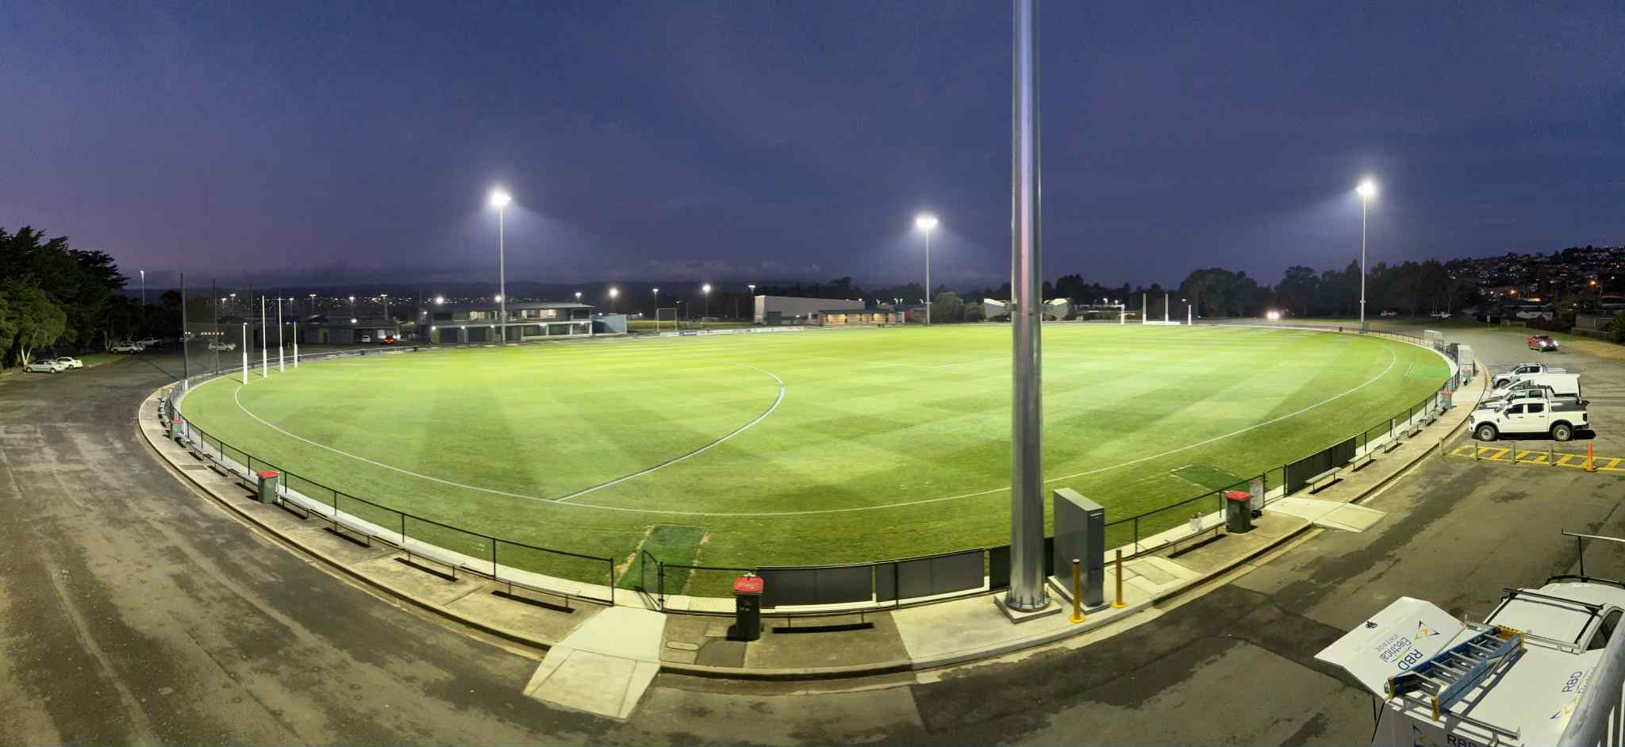
Mayor Holmdahl said that while the total cost for this project is in the vicinity of $2 million, Council fully appreciates just how important these facilities are for our community.
"We are also very grateful for the assistance from AFL Tasmania, which has committed a $74,000 grant to assist council with this project," Mayor Holmdahl said.
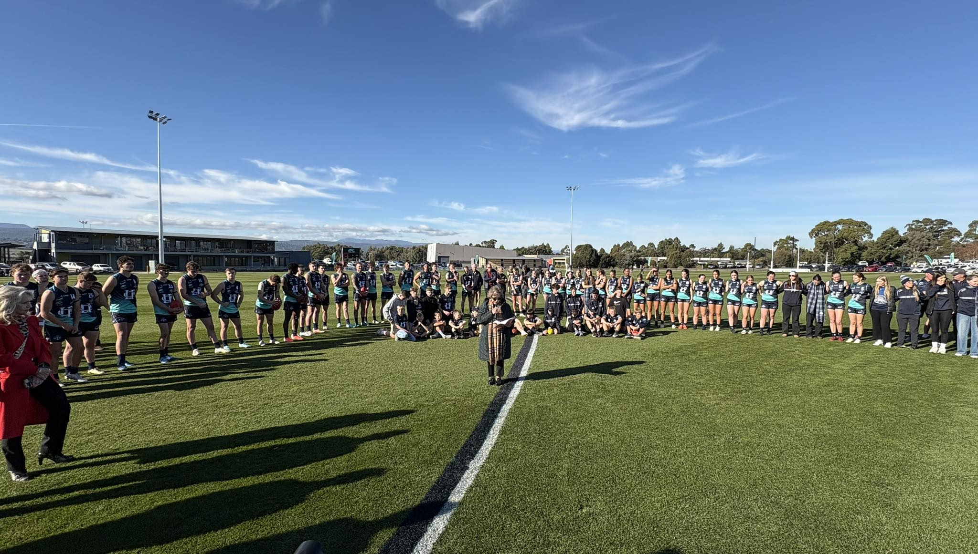
"The rich history of this precinct underscores Windsor Park’s evolution from a football-focused ground to a modern, multi-sport precinct, adapting to community needs through significant investments and innovative maintenance."

Workforce
At the end of the reporting period Council had a headcount of 117 employees. This equated to an establishment of 102.84 FTE.
Council has a total budgeted FTE of 118 establishment for the 2025/26 year.
Council continues to work through the process of filling current staff vacancies.
The workforce profile can be found in the chart below:

Four staff departed Council during this period (including casual and part-time employees), with 9 new staff members joining Council during the same period.
The turnover rate for the quarter was approximately 3.5 per cent.

Incident Reporting

The chart below sets out the April to June 2025 incidents reported along with the total numbers of hazards reported through Council’s Take 5 process.

Description | April | May | June | Total Incidents
Near miss | 1 | 1 | 0 | 2
Minor first-aid injury | 4 | 2 | 0 | 6
Serious injury | 0 | 0 | 0 | 0
Equipment/property/vehicle damage | 7 | 4 | 2 | 13
Psychosocial hazards | 0 | 0 | 1 | 1
Serious or Notifiable incidents | 0 | 0 | 0 | 0
Minor incident (other) | 1 | 1 | 2 | 4
Total incidents | 13 | 8 | 5 | 26

Incident severity | Low | Medium | High | Critical
 | 19 | 7 | 0 | 0

Appendix 1 – Capital Works Program
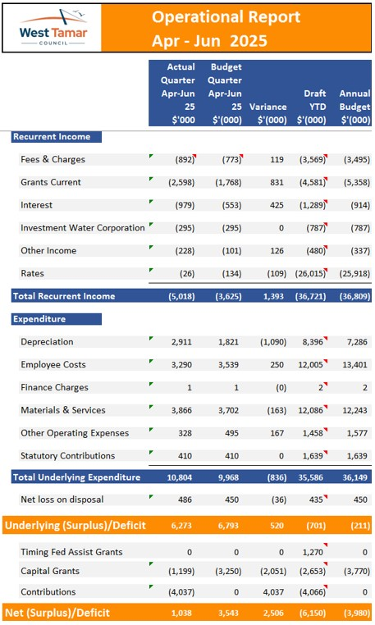
Appendix 1 – Capital Works Program
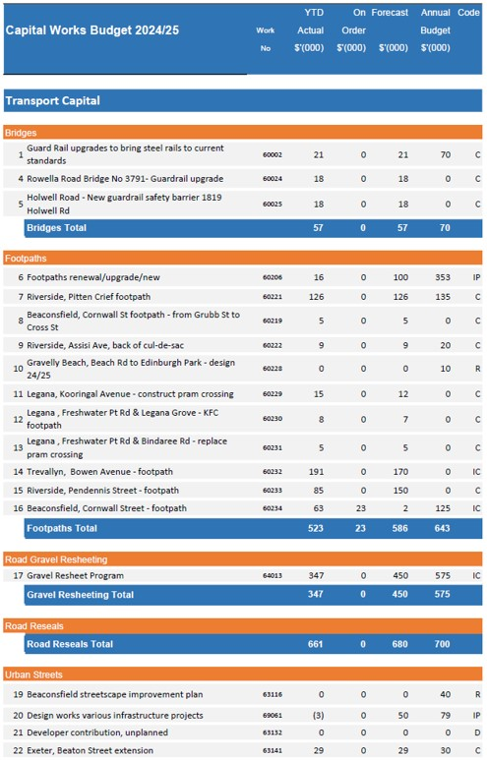
Appendix 1 – Capital Works Program
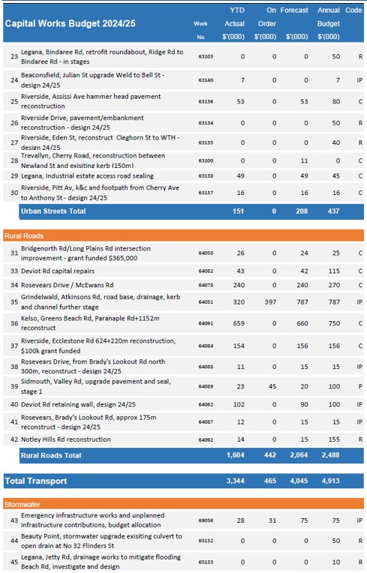
Appendix 1 – Capital Works Program
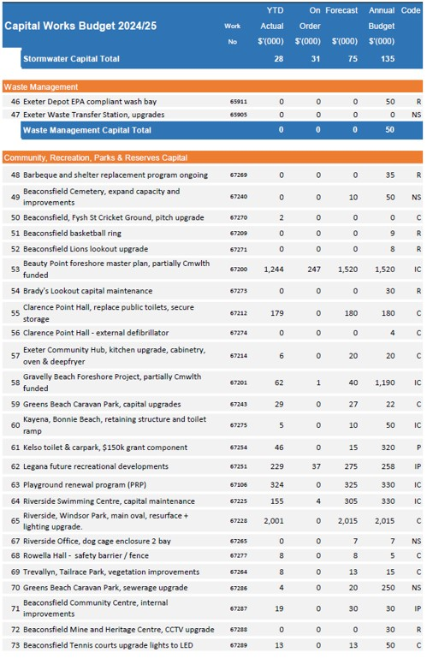
Appendix 1 – Capital Works Program
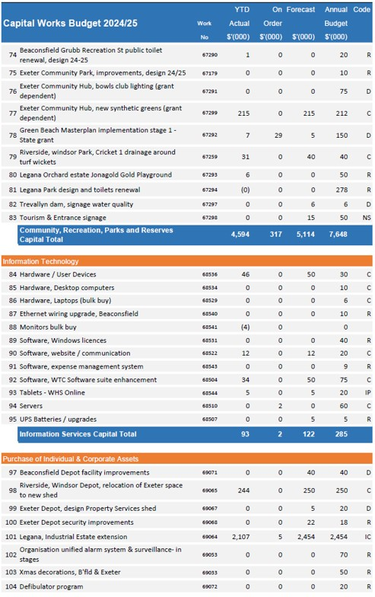
Appendix 1 – Capital Works Program
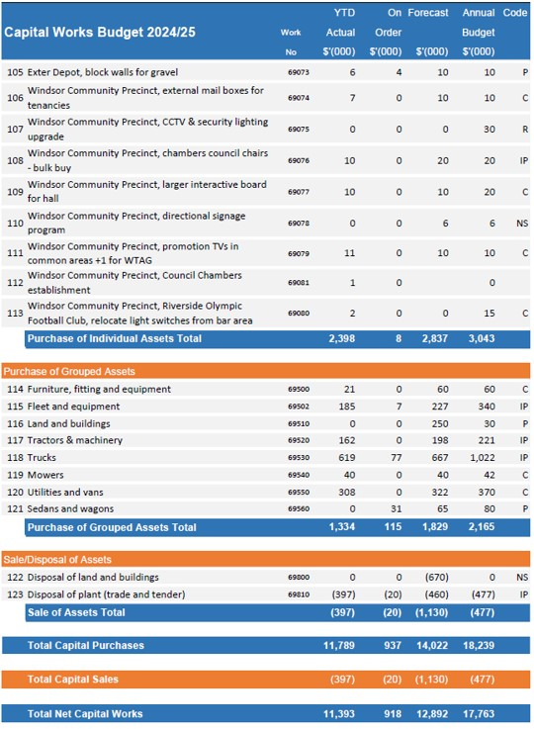
Appendix 1 – Capital Works Program

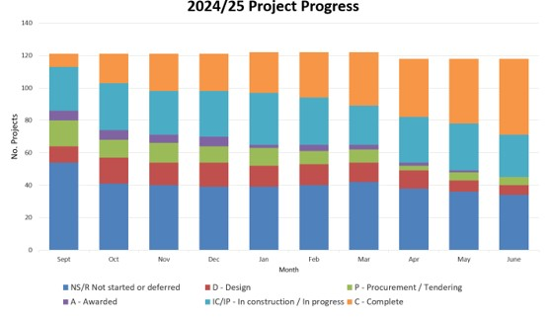

Appendix 2 – Annual Plan Report

No. | Directorate | Annual Plan Action | On Track? | Target Status Q1  July-September | Status Update/Notes | On Track? | Target Status Q2  October-December | Status Update/Notes | On Track? | Target Status Q3  January - March | Status Update/Notes | On Track? | Target Status Q4  April-June | Status Update/Notes
1 | Community Assets | Progression of the Beauty Point Masterplan - including completion of construction for the Esplanade and wharf car parking sections of the project | Progressing as expected | 25% | Construction work in the Esplanade is well underway with completion anticipated in Jan/Feb 2025. | Progressing as expected | 50% | Construction on the Esplanade is expected to be completed mid Feb 2025. Tenders for car park work at the wharf closing early Feb. Quotes under assessment for Sandy Beach access ramp. | Progressing slower than expected | 75% | Construction of work on the Esplanade is completed. Commencement of work on the TasPorts carpark area pending TasPorts approvals. Work has commenced on the Sandy Beach access ramp. | Progressing as expected | 75% | Work on the beach access stairs and TasPorts parking area well under way and nearing completion at 30 June.
2 | Community Assets | Completion of >75 of the precinct 2 works Gravelly Beach Masterplan | Progressing slower than expected | 25% | Some delays experienced in working with the grantor to vary the funding agreement. Design work in progress. | Progressing slower than expected | 25% | Awaiting approval for deed variation. Design 50% complete. | Progressing slower than expected | 25% | Design documentation completed for rescoped precinct 2 works. Tender to be issued in first week of May. | Progressing as expected | 25% | Contract for stage 2 works awarded. Construction scheduled for commencement early September.
3 | Community Assets | Progression of the implementation of the Greens Beach Masterplan including design, procurement and commencement of construction for the Stage 1 works | Progressing as expected | Not Yet Started | Guidance sought from Council, design work anticipated to commence next quarter. | Progressing slower than expected | Not Yet Started | Consultant to be engaged to undertake design work. | Progressing slower than expected | 25% | Request for fee proposal issued to consultants for design work. | Progressing as expected | 25% | Consultant engaged and design work in progress.
4 | Community Assets | Complete stage one civil work works for the Legana Industrial Estate | Progressing as expected | 100% | Works completed as scheduled. | Progressing as expected | 100% | Civil works complete. Substation installation pending | Progressing as expected | 100% | Civil works complete. Substation installation complete. | Progressing as expected | 100% | Completed
5 | Office of the CEO | Commence feasibility study for the West Tamar Trail Strategy Riverside to Legana section | Progressing slower than expected | Not Yet Started | Grant Deed executed in September. Scoping for RFQ commenced. | Progressing slower than expected | 25% | RFQ scoping not yet complete | Progressing slower than expected | 50% | RFQ out at market | Progressing as expected | 100% | Consultant engaged and feasibility study commenced.
6 | Planning & Development | Review of the Legana Structure Plan | Progressing as expected | Not Yet Started | Activity to commence in Quarter 3 | Progressing as expected | Not Yet Started | Activity to commence in Quarter 3 | Progressing as expected | 25% | RFQ released and responded to. Project to be substantially commenced next quarter | Progressing as expected | 50% | Consultant engaged and review commenced.
7 | Planning & Development | Development of the West Tamar Growth Strategy | Progressing as expected | 25% | Consultants engaged and initial investigations commenced | Progressing as expected | 50% | State of Play released and first round of consultation completed | Progressing as expected | 75% | Review of consultation feedback consolidated and work on preferred growth strategy progressing | Progressing as expected | 100% | Draft Growth Strategy received with consultation expected in August 2025
8 | Office of the CEO | Development of a WTC Advocacy Plan | Progressing as expected | Not Yet Started | To be discussed with Council in Quarter 2 | Progressing as expected | 75% | Federal Government Advocacy asks completed. Prospectus to be produced in Q3 | Progressing as expected | 100% | Advocacy prospectus produced and Federal Government lobbied. | Progressing as expected | 100% | Completed.
9 | Corporate & Community | Endorsed WTC Community Health and Wellbeing Plan | Progressing as expected | 100% | WTC Community Health and Wellbeing Plan endorsed by Council at its Ordinary Council Meeting on 17 September 2024. | Progressing as expected | 100% | Completed | Progressing as expected | 100% | Completed | Progressing as expected | 100% | Completed
10 | Corporate & Community | Establishment of a special committee in relation to the Future of the Riverside Pool | Progressing as expected | 100% | Terms of Reference for the Riverside Swimming Centre Redevelopment Advisory Committee were approved by Council at its Ordinary Meeting on 16 July 2024, and amended on 20 August 2024. Committee members were approved by Council on 20 August 2024. | Progressing as expected | 100% | Completed | Progressing as expected | 100% | Completed | Progressing as expected | 100% | Committee formed and meeting regularly
11 | Planning & Development | Scoping and establishment of an Education Program in relation to council's Environmental Health responsibilities | Progressing as expected | Not Yet Started | Planned for Quarter 3 and Quarter 4 | Progressing as expected | Not Yet Started | Planned for Quarter 3 and Quarter 4 | Progressing slower than expected | Not Yet Started | Scheduled for a Q4 activity | Progressing as expected | 100% | Completed - options for an education program have been developed and will be implemented through operational activitiesin 2025-26
12 | Planning & Development | Commence investigations into fire hazards within 5 days of receiving a complaint | Progressing as expected | Not Yet Started | Quarter 2 and Quarter 3 activity | Progressing as expected | 100% | Investigations within fire permit period (declared 19/11/2024) commenced in 5 bd | Progressing as expected | 100% | Investigation and abatement process undertaken and completed | Progressing as expected | 100% | Out of fire season and fire abatements not required at this time
13 | Planning & Development | Completion of the Exeter Structure Plan | Progressing as expected | 50% | Consultants engaged and initial investigations commenced | Progressing as expected | 50% | Consultants progressed investigations and initial concept plans | Progressing as expected | 75% | Presented to Council for direction, consultation and structure plan revisions scheduled for Q4 | Progressing slower than expected | 75% | The Structure Plan has not been completed, however the investigations are complete and the next stage of consultation prior to adoption will occur in coming months.
14 | People, Culture & Safety | Progression of Council's new online Work Health Safety system through to Implementation | Progressing as expected | 25% | 2 of 4 modules implemented | Progressing as expected | 50% | Working on Module 3 | Progressing as expected | 75% | Incident reporting module about to go live | Progressing as expected | 100% | Moving to have completed 4 of the 8 identifed areas of the new systems implementation
15 | People, Culture & Safety | Development of a Council Employee Mental Health Strategy | Progressing as expected | Not Yet Started | Work for 2025, not scheduled to have commenced as yet | Progressing as expected | Not Yet Started | In discussions | Progressing slower than expected | Not Yet Started | Not yet started | Progressing slower than expected | 25% | Discussing with external agency for strategy
16 | People, Culture & Safety | Establishment of a new corporate induction program for all staff | Progressing as expected | 25% | Program is in design stage for rollout in H2 2025 | Progressing as expected | 25% | Outline agreed and being developed for April implementation | Progressing as expected | 50% | Implementation due for Q4. | Progressing as expected | 75% | Progessing for roll out in mid 2025 in line with Scout role out
17 | People, Culture & Safety | Implementation of a new recruitment process | Progressing as expected | 75% | Finalising scope for stage 1 with Onboarding and Talent functions to be implemented in 2025 | Progressing as expected | 75% | Scout/onboarding and Talent active, trial roles being progressed | Progressing as expected | 75% | Scout: Recruit actively used in Q3 with Onboard and Talent to be implemented May/June. Development requirements being addressed with Scout to have system 100% by end of June. | Progressing as expected | 100% | Movement to Scout in the recruitment process is completed and continues to be fine tuned
18 | People, Culture & Safety | Review, modernise and update Council's Recruitment, WHS and Wellbeing Policies | Progressing as expected | 25% | Being reviewed for contemporary practice and legal compliance | Progressing as expected | 25% | Program to be agreed and commenced | Progressing slower than expected | 50% | Will be attempting to get more policy updates up to end of FY | Progressing slower than expected | 25% | Work on time allows
19 | Office of the CEO | Establishment of an Employee Consultative Committee | Progressing as expected | 50% | Requests for nominations for new Employee Consultative Group sent out to all employees | Progressing slower than expected | 50% | Nominations received, initial meeting to be organised. | Progressing as expected | 75% | Inaugural meeting date set for April 2025. Agenda produced. | Progressing as expected | 100% | Committee established and inaugural meeting held
20 | Office of the CEO | Establishment of a new Policy Governance review schedule | Progressing as expected | 50% | Policy Review Schedule drafted out to October 25 across all directorates | Progressing as expected | 50% | Awaiting Councillor review to complete prioritisation | Progressing slower than expected | 50% | Progression slowed due to staff absences | Progressing as expected | 75% | Progressing as expected given staff absences.
21 | Office of the CEO | Completion of a review of the West Tamar Council Risk Register | Progressing slower than expected | Not Yet Started | Review process and schedule to be developed by December 2024 for undertaking in H1 2025 | Progressing as expected | 25% | Initial internal discussions held re engagement of external provider to undertake function | Progressing slower than expected | 50% | Progression slowed due to staff absences further work is expected to occur in early Q4. | Progressing slower than expected | 75% | Consultant now engaged
22 | Corporate & Community | Review and update Council's Social Recovery Plan | Progressing as expected | Not Yet Started | Planned for Quarter 3 and Quarter 4 | Progressing as expected | Not Yet Started | Review to start Feb 25 | Progressing slower than expected | 25% | Will need further work to consider the revised EMP | Progressing slower than expected | 25% | WT MEMP recently updated but still waiting formal adoption. This underpins the SRP so will need consideration as part of review. Additional staff training in recovery centre training has been undertaken. A new SRP template has been introduced and will be used for revision of the plan.
23 | Corporate & Community | Commence a review of the West Tamar Recreation Plan | Progressing as expected | Not Yet Started | Planned for Quarter 3 and Quarter 4 | Progressing as expected | Not Yet Started | RO has returned to role, review to start in Feb | Progressing slower than expected | 25% | Initial review suggests could be refreshed in-house but may wait till Beaconsfield Recreation Plan is finalised | Progressing as expected |  | Aim to undertake review in-house as grant funding not successful. Will need to consider outcomes of Legana and Beaconsfield recreation plans once these are complete
24 | Corporate & Community | Establish and report on a Quarterly Business Sentiment Survey | Progressing as expected | 75% | Survey completed and results currently being collated for information. May be recommended to become an annual survey. | Progressing as expected | 75% | Survey completed, TEDO to report to council in Feb workshop | Progressing as expected | 100% | Survey results and recommendations presented to Council | Progressing as expected | 100% | Survey results and recommendations presented to Council. Next survey to be launch August 2025
25 | Corporate & Community | Continue migration to the relevant Microsoft 365 products | Progressing slower than expected | 75% | Loss of key resources has slowed progress with implementation. | Progressing as expected | 75% | Teams is being rolled out to the organisation | Progressing as expected | 75% | Ongoing preparation for Windows 11 and data transfer to SharePoint | Progressing as expected | 100% | Ongoing preparation for Windows 11 and data transfer to SharePoint
26 | Office of the CEO | Implementation of Doc Assembler | Progressing as expected | 75% | Doc Assembler installed and training for staff completed. Doc Assembler now being utilized for preparation of Council Meeting Agendas and Minutes. Further fine tuning of reports and addition of further agendas to be completed. | Progressing as expected | 75% | Fine tuning of reports continuing, further agendas under consideration | Progressing as expected | 100% | Doc Assembler usage for preparation of Agendas and Minutes for Council meetings fully embedded. Audit Panel Agendas set up and testing in progress. | Progressing as expected | 100% | Implementation completed. Expansion of usage underway.
27 | Office of the CEO | Complete brand refresh | Progressing as expected | 75% | Final designs to be provided and embedded. | Progressing as expected | 75% | New logo and letterhead starting to be implemented throughout organisation. Rollout continuing. | Progressing as expected | 75% | Brand refresh complete roll-out in progress. Expected to be completed by end of Q4 | Progressing as expected | 100% | Completed.
28 | Office of the CEO | Complete establishment and implementation of a new Council website | Progressing as expected | 25% | Council's communications officer continues to complete the required data migration, | Progressing as expected | 50% | Migration of content about 80 per cent complete. There have been some issues with the direct payment system (held up by ReadyTech/Synergy) with developers now working on interface. This has caused some delays well beyond our control. | Progressing as expected | 100% | New website launched in March 2025. Further development to improve online accessibility underway. | Progressing as expected | 100% | Completed.
29 | People, Culture & Safety | Review and updating of all Volunteer processes including inductions | Progressing as expected | Not Yet Started | Work for 2025, not scheduled to have commenced as yet | Progressing as expected | Not Yet Started | To be actioned | Progressing slower than expected | Not Yet Started | Not Yet Started | Progressing slower than expected | 25% | To be progressed. Inital work completed.
30 | Corporate & Community | Ensure that outstanding rates meet the following thresholds: 30 September 2024 55%, 31 December 2024 35%, 31 March 2025 19%, 30 June 2025 5% | Progressing as expected | 100% | As at 30 September outstanding rates was 53.9%. | Progressing as expected | 100% | Within targets | Progressing as expected | 100% | Within targets | Progressing slower than expected | 75% | Rates Outstanding 5.6% Result 30 June 2025
31 | Corporate & Community | Completion of the Legana Community Sport and Recreation Precinct Masterplan | Progressing as expected | 25% | Request for tender completed and consultant appointed August 2024 | Progressing as expected | 25% | Council has been briefed, community consultation to take place in QRT3 | Progressing as expected | 75% | Concepts have been completed and community consultation commenced | Progressing slower than expected | 75% | Some delays in finalising concepts due to consideration of further community feedback. Final concepts to be presented to Council in August 2025
32 | Community Assets | Completion of a draft storm water plan for Green's Beach | Progressing as expected | Not Yet Started | Proposals to be obtained from consultants to undertake the required work | Progressing as expected | Not Yet Started | Proposals to be obtained from consultants to undertake the required work | Progressing slower than expected | Not Yet Started | Consultant fee proposal received. To be assessed. | Progressing as expected | 25% | Consultant engaged and catchment modelling work in progress.
33 | Corporate & Community | Completion of a Draft Beaconsfield Recreation Plan | Progressing as expected | Not Yet Started | Planned for Quarter 3 and Quarter 4 | Progressing as expected | 25% | Internal committee established starting in Feb 25 | Progressing slower than expected | 50% | RFP drafted and prepared for advertising in Q4 | Progressing slower than expected | 50% | Consultant appointed in June 2025 - project completion due December 2025.
34 | Office of the CEO | Publication of a Quarterly Performance Report | Progressing as expected | 25% | 4th Quarter Performance Report April to June 2024 approved by Council in August 2024. | Progressing as expected | 50% | 1st Quarter Performance report July to September 2024 approved by Council in November 2024. | Progressing as expected | 75% | 2nd Quarter Performance Report October to December 2024 approved by Council in February 2025. | Progressing as expected | 100% | 3rd Quarter Performance Report January to March 2025 approved by Council in May 2025.
35 | Community Assets | Ongoing Monitoring and reporting on Legana Landslip | Progressing as expected | 25% | Information report prepared for Council Workshop. Level survey scheduled for early Quarter 2. | Progressing as expected | 50% | Technical working group reviewing latest survey data. Landowner meetings to be scheduled for mid-March | Progressing as expected | 75% | Consultant engaged for technical review of monitoring data. Site inspections completed. Technical working group meetings convened. Letter sent to landowners. Meeting rescheduled to occur after landslide technical review report submitted. | Progressing as expected | 100% | Draft report submitted for review. To be presented to Council Workshop early in new FY.
36 | Office of the CEO | Completion of an Organisational Review | Progressing as expected | 50% | Survey undertaken and report prepared. | Progressing as expected | 75% | Staff and Council consultation undertaken on report results, feedback requested and consolidated. Implementation of changes started. | Progressing as expected | 75% | Implementation of changes continued. Organisational charts provided to each Directorate for final feedback. | Progressing as expected | 100% | Completed.
37 | Community Assets | Progress Legana Orchards Playground | Progressing as expected | Not Yet Started | Procurement activity to commence Quarter 2 | Progressing as expected | 50% | Preliminary concept work undertaken. Project scope to be discussed at Council Workshop 18 Feb | Progressing as expected | 75% | Budget increase proposed for increased scope of work. Communication collateral being prepared for consultation with community on playground elements. | Progressing as expected | 100% | Community consultation phase in progress.
38 | Community Assets | Complete Beaconsfield streetscape concept plans | Progressing as expected | Not Yet Started | Information to be prepared and presented to Council Workshop for discussion | Progressing slower than expected | Not Yet Started | Information to be prepared and presented to Council Workshop for discussion in March | Progressing slower than expected | Not Yet Started | Workshop material to be prepared for discussion at Council Workshop in final quarter. | Progressing slower than expected | Not Yet Started | Not yet started.
39 | Community Assets | Complete design and construction of scheduled footpath work in Beaconsfield | Progressing as expected | Not Yet Started | Project work to commence in Quarter 2 | Progressing slower than expected | Not Yet Started | Design work to commence March | Progressing slower than expected | 50% | Design work completed. Tender documentation to be issued in May for pricing. | Progressing as expected | 75% | Construction of Cornwall Street footpath well underway at 30 June.
40 | Community Assets | Ensure third party safety compliance inspections of playgrounds have occurred and recommendations are actioned appropriately | Progressing as expected | 25% | Inspections commenced, majority scheduled for Quarter 2 | Progressing as expected | 50% | Third party inspections complete. Recommended actions in progress. | Progressing as expected | 75% | Third party inspections complete. Work to address recommendations for improvement in progress. | Progressing as expected | 100% | Third party inspections complete. Work to address recommendations for improvement ongoing.
41 | Office of the CEO | Development of a Climate Mitigation and Adaptation Strategy | Progressing as expected | 50% | Initial draft completed based on NTARC work undertaken for WTC. Draft to be discussed with Councillors at the next available workshop. | Progressing as expected | 75% | In person workshops undertaken with staff and NTARC. Work undertaken to collate information to further expand draft Strategy. | Progressing slower than expected | 75% | Ongoing presentations to Executive team and timeline locked in for presentation to Council for consideration early in Q4 | Progressing as expected | 100% | The strategy was provided to a Council workshop in June and was approved to be sent to the graphic designer. To be presented to Council at the July Ordinary Meeting for endorsement.
*NB Progress on Annual Plan Actions is monitored by a traffic light system:
- Green for “Progressing as Expected”
- Amber for “Progressing Slower than Expected”
- Red for “Not Progressing”

Appendix 3

Outstanding Motions
Note: Council motions that are completed will be removed from this list for the next Quarterly Reporting period

Minute No. | Date | Motion | Resolution | Action
Office of the Chief Executive Officer
24/140 | 19/11/2024 | Cr Sladden - Motion on Public Advocacy on Reported DNA Contamination in COVID-19 Vaccines  As per resolution |  | Completed - Ongoing
24/175 | 17/12/2024 | Cr Sladden - Motion to Live Stream video of Council Meetings  That the motion be deferred. |  | Deferred
24/176 | 17/12/2024 | Cr Manticas - Motion to implement audio recordings of confidential sessions of Council  That the motion be deferred. |  | Completed
25/32 | 18/03/2025 | Cr Holmdahl - Motion on WT Highway reclassification, speed reduction and resurfacing between Riverside and Legana  As per resolution |  | Completed
25/34 | 15/04/2025 | Confirmation of Minutes of Meeting held 18 March 2025  That the Minutes of Council's Ordinary Meeting held on 18 March 2025 numbered 25/20 to 25/33 as provided to Councillors be received and confirmed as a true record of proceedings |  | Completed
25/36 | 15/04/2025 | CEO 1 - Council Workshops held in March and April  That Council receives the report on Council Workshops held on 18 March, 25 March, 1 April and 8 April 2025 |  | Completed
25/37 | 15/04/2025 | CEO 2 - Request for Funding - Exeter Show Society  That Council:  - Approve an allocation of $20,000 per financial year for three (3) years from 2025/26 to 2027/28 with the following conditions:  - An annual acquittal is to be completed by the end of August each year  - That the Exeter Show Society is excluded from applying for West Tamar Council Community or Business Grants for 3 years  - Any unexpended funds from the $20,000 annual allocation is to be returned to Council. |  | Completed
25/38 | 15/04/2025 | CEO 3 - ALGA 2025 Federal Election Funding Priorities  That Council:  - Supports the national federal election funding priorities identified by the Australian Local Government Association;  - Supports and participates in the Put Our Communities First federal election campaign; and  - Writes to the local Federal member of Parliament, all known election candidates in the electorate of Bass and the President of the Australian Local Government Association expressing support for ALGA's federal election funding priorities. |  | Completed
25/39 | 15/04/2025 | CEO 4 - Recording of Confidential Ordinary Council Meetings  That Council:  - develops an Audio Recording and Minutes Policy for consideration by Council at the June 2025 Ordinary Council meeting, to include the audio recording of confidential sessions of Ordinary Council Meetings. |  | Completed
25/46 | 15/04/2025 | Pet 1 - Petition to Reduce Speed Limit - Winkleigh Road  That Council:  - Notes the receipt of the petition;  - Undertakes a review of the road corridor along Winkleigh Road from 76 Winkleigh Road to the Crawford Road junction with a view to a potential speed limit reduction with the results of that review presented at the first available workshop.
25/47 | 15/04/2025 | Into Closed Meeting  As per resolution. |  | Completed
25/C18 | 15/04/2025 | Confirmation of Minutes of Closed Meeting held 18 March 2025  That the Minutes of Council's Closed Ordinary Meeting held on March 2025 numbered 25/C15 to 25/C17 as provided to Councillors be received and confirmed as a true record of proceedings. |  | Completed
25/C19 | 15/04/2025 | Confidential 1 - Authority to enter into a Contract of sale of land  As per resolution |  | Completed
25/C21 | 15/04/2025 | Move Out of Closed Meeting  That Council:  - moves out of Closed Meeting at 5.34pm; and  - endorses those decisions made while in Closed Meeting; and  - the information remains Confidential unless authorised to be released at the Chief Executive Officer's discretion |  | Completed
25/48 | 20/05/2025 | Confirmation of Minutes of Meeting held 15 April 2025  That the Minutes of Council's Ordinary Meeting held on 15 April 2025 numbered 25/34 to 25/48 as provided to Councillors be received and confirmed as a true record of proceedings. |  | Completed
25/52 | 20/05/2025 | CEO 1 - Council Workshops held in April and May 2025  That Council receives the report on Council Workshops held on 15 April and 6 May 2025. |  | Completed
25/53 | 20/05/2025 | CEO 2 - New Policy - Dispute Resolution Policy  That Council refuse to adopt the Dispute Resolution Policy as presented. |  | Completed
25/54 | 20/05/2025 | CEO 3 - Submission to Minister for Infrastructure on second kanamaluka/River Tamar crossing  That Council:  - Endorses the submission to the Minister for Infrastructure in relation to a second crossing of the Kanamaluka/River Tamar included in Attachment 1; and  - Authorises the Mayor to sign the submission on their behalf. |  | Completed
25/55 | 20/05/2025 | CEO 4 - 3rd Quarter Performance Report - January to March 2025  That Council:  - Receives the West Tamar Council 3rd Quarter Performance Report 1 January 2025 to 31 March 2025; and  - Provides public access to the report as part of Council's commitment to ongoing good governance |  | Completed
25/62 | 20/05/2025 | Into Closed Meeting  As per resolution |  | Completed
25/C22 | 20/05/2025 | Confirmation of Minutes of Closed Meeting held 15 April 2025  That the Minutes of Council's Closed Ordinary Meeting held on 15 April 2025 numbered 25/C18 to 25/C21 as provided to Councillors be received and confirmed as a true record of proceedings. |  | Completed
25/C23 | 20/05/2025 | Adoption of the Chief Executive Officer Performance Agreement 2024/25  As per resolution |  | Completed
25/C24 | 20/05/2025 | Local Government Association of Tasmania (LGAT) - 2025 Elections  As per resolution |  | Deferred
25/C26 | 20/05/2025 | Move Out of Closed Meeting  That Council:  - moves out of Closed Meeting a 3.57 pm; and  - endorses those decisions made while in Closed Meeting; and  - the information remains Confidential unless authorised to be released at the Chief Executive Officer's discretion |  | Completed
25/63 | 17/06/2025 | Confirmation of Minutes of Meeting held 20 May 2025  That the Minutes of Council's Ordinary Meeting held on 20 May 2025 numbered 25/48 to 25/62 as provided to Councillors be received and confirmed as a true record of proceedings. |  | Completed
25/66 | 17/06/2025 | CEO 1 - Council Workshops held in May and June  That Council receives the report on Council Workshops held on 20 May 2025 and 3 June 2025. |  | Completed
25/67 | 17/06/2025 | CEO 2 - Business Events Tasmania - Memorandum of Understanding  That Council:  - Approves West Tamar Council entering into a further Memorandum of Understanding with Business Events Tasmania on the terms contained in the draft Memorandum of Understanding attached to this paper; and  - Authorises the Chief Executive Officer to sign the Memorandum of Understanding and return it to Business Events Tasmania on its behalf. |  | Completed
25/68 | 17/06/2025 | CEO 3 - Visit Northern Tasmania - Partnership Agreement  That Council:  - Approves West Tamar Council to enter into a further Partnership Agreement with Tourism Northern Tasmania Inc's (trading as Visit Northern Tasmania) on the terms contained in the draft Funding Agreement attached to this paper; and  - Authorises the Chief Executive Officer to sign the Partnership Agreement and return it to Tourism Northern Tasmania Inc's (trading as Visit Northern Tasmania) on its behalf. |  | Completed
25/69 | 17/06/2025 | Gov 1 - West Tamar Council Audit Panel Minutes  That Council receives and notes the confirmed Minutes of the Audit Panel meeting held on 25 March 2025 and the unconfirmed Minutes of the Audit Panel meeting held on 4 June 2025. |  | Completed
25/70 | 17/06/2025 | Gov 2 - West Tamar Council Audit Panel Annual Report 2024-2025  That Council receives for information the Audit Panel Annual Report 2024-2025. |  | Completed
25/71 | 17/06/2025 | Gov 3 - West Tamar Council Audit Panel Annual Work Plan 2025-2026  That Council approves the adoption of the 2025-2026 Annual Work Plan as presented. |  | Completed
25/72 | 17/06/2025 | Gov 4 - New Policy - Audio Recording and Minutes Policy  That Council:  - Adopts the new Audio Recording and Minutes Policy as presented, effective 17 June 2025;  - Allocates a new policy number of 68.00;  - Updates the version number to 1.00; and  - Approves a review date of June 2027. |  | Completed
25/76 | 17/06/2025 | Cr Manticas - Motion regarding Bell Bay Advanced Manufacturing Zone  That Council:  - Writes to the Chief Executive Officer of the Bell Bay Advanced Manufacturing Zone (BBAMZ) requesting an urgent briefing to be provided to the elected members of West Tamar Council regarding the current and future operations of the Bell Bay industrial precinct; and  - Specifically seeks information and strategic insight into the broader implications of any operational changes at key facilities within the precinct, including Liberty Bell Bay, and how these may affect the local economy, employment opportunities, and future industrial investment across the region. |  | Completed
25/77 | 17/06/2025 | Cr Shegog - Motion Without Notice regarding the LGAT Alternative Dispute Resolution Policy  That West Tamar Council Chief Executive Officer write to the leaders of the Liberal, Labor and Greens Party, expressing our concerns surrounding new legislation surrounding the Local Government Code of Conduct in relation to the new Alternative Dispute Resolution Policy, to ensure any vexatious matters or complaints can be dismissed at the earliest opportunity. |  | Completed
25/78 | 17/06/2025 | Cr Shegog - Motion Without Notice regarding the Sending of Condolences to the Commissioner of Police  That the Chief Executive Officer writes to the Commissioner of Police sending condolences on behalf of the West Tamar Community of the sad and terrible loss of Constable Keith Smith in a tragic shooting in the State's North West yesterday. |  | Completed
25/79 | 17/06/2025 | Into Closed Meeting  As per resolution |  | Completed
25/C27 | 17/06/2025 | Confirmation of Minutes of Closed Meeting held 20 May 2025  That the Minutes of Council's Closed Ordinary Meeting held on 20 May 2025 numbered 25/C23 to 25/C26 as provided to Councillors be received and confirmed as a true record of proceedings. |  | Completed
25/C28 | 17/06/2025 | Leave of Absence Requests  As per resolution |  | Completed
25/C29 | 17/06/2025 | Late Confidential - Motion to accept late items  As per resolution |  | Completed
25/C30 | 17/06/2025 | Late Confidential 1 - Election of an acting Deputy Mayor  As per resolution |  | Completed
25/C31 | 17/06/2025 | Confidential 1 - Local Government Association of Tasmania (LGAT) - 2025 Elections  As per resolution |  | Completed
25/C32 | 17/06/2025 | Confidential 2 - Authority to enter into negotiations for contract of sale of land  As per resolution |  | In Progress
25/C35 | 17/06/2025 | Move Out of Closed Meeting  That Council:  - moves out of Closed Meeting at 3.47pm; and  - endorses those decisions made while in Closed Meeting; and  - the information remains Confidential unless authorised to be released at the Chief Executive Officer's discretion |  | Completed
Corporate & Community
25/41 | 15/04/2025 | Corp 1 - West Tamar Council Audit Panel Minutes  That Council receives and notes the confirmed Minutes of the Audit Panel meeting held on 11 December 2024 and the unconfirmed Minutes of the Audit Panel meeting held on 25 March 2025. |  | Completed
25/42 | 15/04/2025 | Comm 1 - Community Grant Application - Birralee and Districts Pony Club  That Council:  - Approve Birralee & Districts Pony Club community grant application for the installation of an AED cabinet and replacement battery/pads for $671.00 |  | Completed
25/43 | 15/04/2025 | Comm 2 - Community Grant Application - Exeter Bowls and Community Club  That Council:  - Support the application for funding from the Exeter Bowls and Community Club CLUBMAP Packages/Programs to the value of $4997.80. |  | Completed
25/44 | 15/04/2025 | Comm 3 - Community Grant Application - West Tamar Dance Academy  That Council:  - Does not approve the community grant application by West Tamar Dance Academy for $10,000 for the purchase and installation of a wooden floor. |  | Completed
25/45 | 15/04/2025 | Comm 4 - Sponsorship Application - Festival of Voices  That Council:  - Approve a one year sponsorship of $2,165 for the 2024/25 financial year, including $165 payable for hire of the hall for the Festival of Voices Sip N Sing. |  | Completed
25/C20 | 15/04/2025 | Confidential 2 - Sale of property for unpaid rates  As per resolution |  | Completed
25/57 | 20/05/2025 | Com 1 - Sponsorship Application - Family Christmas Carols Event  That Council approves the sponsorship application submitted by the Tamar Valley Christian Church Inc. for future funding of the annual Family Christmas Carols subject to the following conditions:  - That West Tamar Council and Tamar Valley Christian Church Inc. develop and agree to a Memorandum of Understanding acceptable to Council's Chief Executive Officer that will outline the obligations of both parties;  - That West Tamar Council has exclusive naming rights of the Carols; and  - That Council's sponsorship contribution is limited to $15,000 per annum for 2025/26, 2026/27 and 2027/28. |  | Completed
25/58 | 20/05/2025 | Com 2 - Sponsorship Application - Launceston Chamber of Commerce Excellence Award  That Council:  - Supports the Launceston Chamber of Commerce request by providing sponsorship funding of $4,700 (plus GST) in 2025/2026 to sponsor the category of Exceptional Workplace at its 2025 Business Excellence Awards. |  | Completed
25/59 | 20/05/2025 | Com 3 - Sponsorship Application - Tamar Valley Wine Route - Taste of the Tamar  That Council:  - approves a one-year sponsorship of $8,000 for the 2025 Taste of the Tamar event to be held at the Exeter Showgrounds, to be funded from Council's 2025-2026 sponsorship budget. |  | Completed
25/60 | 20/05/2025 | Com 4 - Community Grant Application - Tamar Sea Rescue  That Council:  - Approve Tamar Sea Rescue's community grant application to the amount of $4,455.00 for the upgrading of the electrical switchboard at its Inspection Head base. |  | Completed
25/73 | 17/06/2025 | Corp 1 - Related Party Disclosures Policy  That Council:  - Rescinds the existing Related Party Disclosures Policy (WT-HRM 41.00 April 2021);  - Adopts the updated Related Party Disclosures Policy as presented, effective 17 June 2025;  - Updates the version number to 3.00; and  - Approves a review date of April 2029. |  | Completed
25/74 | 17/06/2025 | Corp 2 – 2025/2026 Estimates and Rates and Charges  As per resolution |  | Completed
25/75 | 17/06/2025 | Corp 3 - Fees and Charges for 2025/2026 Financial Year  As per resolution |  | Completed
25/C33 | 17/06/2025 | Confidential 3 – Windsor Café Operations  As per resolution |  | Completed
Planning & Development
25/22 | 18/03/2025 | Plan 2 - AMD03/24 - Amendment to the Planning Scheme for land at 11 Upper McEwans Road, Legana (CT174506/1) and Planning Application PA2024132 to subdivide the land into three (3) lots  As per resolution |  | Completed
25/35 | 15/04/2025 | Plan 1 - PA2024139 - Multiple Dwellings (2 New, 1 Existing) - 39 Freeland Crescent, Riverside  As per resolution |  | Completed
25/40 | 15/04/2025 | Dev 1 - Submission to Land Use Planning and Approvals Amendment (Development Assessment Panel) Bill 2025 (Ver.2)  That Council:  - Endorse the submission to the Land Use Planning and Approvals Amendment (Development Assessment Panels) Bill 2025 included as Attachment 1; and  - Authorises the Chief Executive to sign the submission on Councils behalf. |  | Completed
25/49 | 20/05/2025 | Plan 1 - PA2025037 - Subdivision 1 into 2 Lots - Allen Street with access over 115 Top Road West, Greens Beach  As per resolution |  | Completed
25/50 | 20/05/2025 | Plan 2 - PA2024312 - Subdivision - 1 into 9 Lots, Boundary Adjustment and New Road - 1306 West Tamar Road and Ridge Road, Legana  As per resolution |  | Completed
25/51 | 20/05/2025 | Plan 3 - AMD03/24 - Amendment to the Planning Scheme for land at 11 Upper McEwans Road, Legana (CT174506/1) and Planning Application PA2024132 to subdivide the land into three (3) lots  As per resolution |  | Completed
25/56 | 20/05/2025 | Dev 1 - Environmental Health and Municipal Fees and Charges 2025/26  As per resolution |  | Completed
25/64 | 17/06/2025 | Plan 1 - PA2024152 - Residential - 7 x Outbuildings (Retrospective) and resurfacing of existing gravel area - 19 Lachlan Parade, Trevallyn  As per resolution |  | Completed
25/65 | 17/06/2025 | Plan 2 - PA2025092 - Residential - Dwellings (2 new, 1 existing) - Lot 1 Greens Beach Road, Greens Beach  As per resolution |  | Completed
Community Assets
153/23 | 19/12/2024 | Infra 1 – Speed Limit Review Overview  That Council:  - Endorses the priority list of works as set out above; and  - Authorises the Chief Executive Officer to prepare all necessary documents for submission to the Department of State Growth for consideration. |  | In Progress
25/61 | 20/05/2025 | Asset 1 - Capital Works Budget Variations  That Council receives this report under the Local Government Act 1993 section 82(7) noting the capital works project budget adjustments approved under delegation by the Chief Executive Officer. |  | Completed
25/C34 | 17/06/2025 | Confidential 4 - Contract WTC 03/2025 Gravelly Beach Village Centre Upgrade  As per resolution |  | Completed

