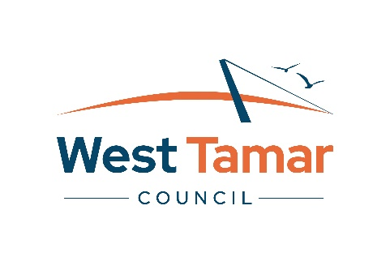
2025/2026 Business Grant Application Form

Applicant Details
Organisation/Group Name
ABN (if applicable)
Postal Address
Email Address
Contact Name
Contact Number
Community Services Team liaison or contact person
Is your organisation registered for GST? |  | Yes | No

Project Overview
Project Name
Project Location
Project Dates
Grant Funding Amount Requested
Project Overview - Describe your project in a short description (50 - 250 words)

Business Case & Rational
- Assessment Value 20%
- 300 – 600 words recommended
- Applicants must clearly describe the purpose of their project and explain the specific business need, challenge, or opportunity it addresses.
- The explanation should link the project to a current business plan or broader regional priorities where possible.
- Applicants should show why the project is necessary now and how it fits with both the immediate goals and long-term direction of the business.
- All statements should be supported by evidence, such as customer or stakeholder feedback, market research, industry data, or case studies.
- The application should provide context about why this project is important, what will happen if it does not proceed, and include data or examples that demonstrate the urgency and relevance of the proposal for the business’s ongoing success.

Local Economic Benefit
- Assessment Value 20%
- 300 – 700 words recommended
- Applicants must clearly explain how their project will create lasting benefits for the West Tamar local economy.
- Information provided can include specific details about the number of jobs created or enhanced, increased use of local suppliers, higher sales or business turnover, or stronger service offerings in the area.
- Where possible, applicants should use numbers and data to show the scale of these benefits.
- Applications should also describe any wider positive effects for the community or region, and how the project is linked to local or state economic strategies or goals.
- It’s important for applicants to explain how they will track and measure these economic benefits during and after the project, and outline how progress will be reported.

Innovation and Growth
- Assessment Value 20%
- 300 – 500 words recommended
- Applicants must clearly describe what is new or different about their project—such as new products, services, technology, or ways of working.
- Explain how these changes will help the business become more resilient, competitive, or able to grow in a sustainable way.
- The application should make clear how the project is unique for the local area or industry, and outline what measurable improvements (for example, increased market share, better efficiency, or new capabilities) will result directly from the project.
- Where possible, evidence should be provided to show the benefits and originality of the approach.

Project Delivery
- Assessment Value 20%
- 300 – 600 words recommended
- Applicants must provide a simple, step-by-step plan showing how their project will be completed.
- This should include key activities, a clear timeline, and the people responsible for delivering each part.
- List any required permits or approvals, and outline relationships with partners or suppliers that will help deliver the project.
- Applicants should be able to show that they have the necessary skills, experience, and resources to successfully deliver the project.
- The plan must include ways to identify challenges or risks and explain how these will be managed. Applicants should also explain how they will track progress and make sure the project stays on track until completed.

Budget and Value for Money
- Assessment Value 20%
- 200 – 400 words recommended
- Applicants must provide a detailed budget that lists all project costs and funding sources.
- Every item should be clearly described and, where possible, backed up with quotes or realistic estimates.
- The budget must show how council funds will be used in a cost-effective way, meaning applicants should clearly link the costs to project outcomes and explain why each expense is necessary.
- A minimum of 10% co-contribution from the applicant or other external funds is required.
- Applicants should demonstrate that the requested funding provides good value for return.
- The budget should make it clear that public funds will be used responsibly, and the project is financially ready and able to follow proper acquittal and reporting requirements.

Project Expenditure
Include all cost associated with the project and attached quotes (inclusive of GST, if applicable).
Expenditure Description | $
Expenditure Total
Project Income – Include all confirmed funding and donations, including materials.
Income Description: | $
Income Total
All relevant quotes are attached

Declaration
By signing and submitting this form I declare that the information given in this application is true and accurate to the best of my knowledge.

Once the project is finalised, it is a requirement that an acquittal form is completed within 6 weeks of the projected project delivery date as outlined in the funding agreement.

I agree to liaise with Council, if there are any changes to the project delivery and to submit and acquittal form within six (6) weeks of the project’s completion.

Name
Role/Position
Signature
Date

Application Checklist
Before you lodge your application, check that you have provided all the required details and documents and check that your budget is accurate and complete.

The following may assist you, check that you have:
Checked eligibility against the guidelines
Contacted the Community Services Team on 6323 9200 prior to applying
Completed all sections of application form (incomplete applications will not be assessed)
Attached relevant supporting documents (quotes matching the budget, permits, insurances, letters of support etc.)
Kept a copy of your application
Signed the completed application

