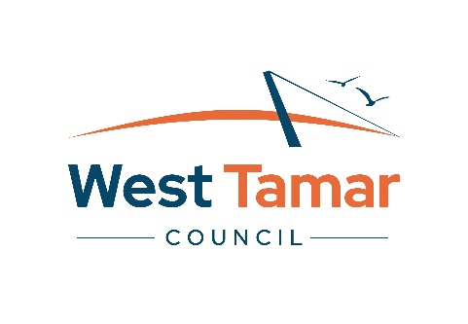

2026/2027 Business Grant Application Form

Applicant Details
Business Name
ABN
Business Address
Contact Name
Role/Position
Contact Phone Number
Email Address

Website

Google Business profile

Does your business have a parent company? |  | Yes | No
Is your business registered for GST? |  | Yes | No
Is your business a Brand Tasmania Partner?  https://tasmanian.com.au/for-partners/ |  | Yes | No
Is your business listed on the Australian Tourism Datawarehouse (ATDW)? |  | Yes | No
Is your business aligned with an industry accreditation or association body?  If yes, please list indicate which ones |  | Yes | No

Project Overview
Project Name
Project Location
Funding Amount Requested
If you were to receive partial funding, what is the minimum funding amount required for this project to continue?

If your application is unsuccessful for funding, will the project still go ahead? | Yes  No
Does your project require any permits, development approvals, or licensing?

Applications are invited to include visual attachments to represent the proposed project.

Business Case & Rational
Value 30% | 300 – 600 words recommended

Local Economic Impact
Value 30% | 300 – 600 words recommended

Project Delivery and Success Metrics
Value 20% | 300 – 600 words recommended

Theme alignment
Value 10% | 150 – 300 words

Budget and Value for Money
Value 10% | 200 – 400 words recommended

Forecast Budget
Expenditure Description | $
Expenditure Total
Income Description: | $
A minimum of 10% co-contribution from the applicant
West Tamar Council – Grand Funding Requested
Income Total
All relevant quotes for these expenses are attached

Declaration
By signing and submitting this form I declare that the information given in this application is true and accurate to the best of my knowledge.

Once the project is finalised, it is a requirement that an acquittal form is completed within 6 weeks of the projected project delivery date as outlined in the funding agreement.

I agree to liaise with Council, if there are any changes to the project delivery and to submit and acquittal form within six (6) weeks of the project’s completion.

Name
Role/Position
Signature
Date

Application Checklist
Before you lodge your application, check that you have provided all the required details and documents and check that your budget is accurate and complete.

The following may assist you, check that you have:
Checked eligibility against the guidelines
Contacted the Community Services Team on 6323 9200 prior to applying
Completed all sections of application form (incomplete applications will not be assessed)
Attached relevant supporting documents
(quotes matching the forecast budget, permits, development applications, insurances, letters of support etc.)
Retained a copy of your application
Signed the completed application

